are created equal. Because of that, it can be difficult to tell which type is best for your project. Two of the most common casting processes are die casting and sand casting. Let’s take a look at each term, how the processes are different, and why you should choose one process over the other for your next project.

**[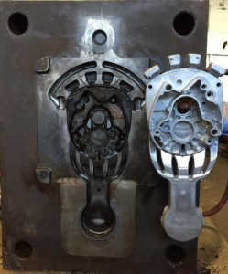](https://diecasting.com/blog/wp-content/uploads/2015/10/die-cast-mold.jpg)**

**What Is Die Casting?**

In the die casting process, liquid or “molten” metal is forced into a die under high pressure. In this case, “die” refers to the steel mold created to shape the actual product that will be made. Following the pour and injection into the mold, the molten metal solidifies and is removed from the mold. When the metal cools, the gating material gets removed and a product has been manufactured! The steel mold can then be closed and prepared for the next “shot,” which allows it to be reused immediately. The cycle on making a die cast part can be from 30 seconds to one minute, making the process extremely fast. **The image to the left shows the ejector half of a die cast mold and the shot from the mold on the right.**

**[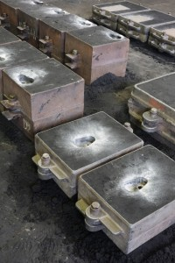](https://diecasting.com/blog/wp-content/uploads/2015/10/sand-molded-castings.jpg)**

**What Is Sand Casting?**

In the sand casting process, molten metal is poured directly from a ladle into a sand mold – no high pressure necessary. The mold is created when a pattern made out of wood or plastic — typically called a matchplate — is placed inside an enclosure. Sand is then filled in around the matchplate and inside the enclosure. Once the sand is added and packed densely, the matchplate is removed and the remaining cavity is filled with molten metal. Following the pour, the metal solidifies, the mold is opened and the sand is shaken off the hot casting, which leads to a product being manufactured. At this point, the gating material can be removed and the casting is complete.